 It's too time-consuming to go over all the reports manually, providing summary report can better equip bankers/RMs and executives who deal with clients. There are multiple research reports on sector/industry/company/instruments from many different sources. these reports can be used to educate clients as well through digital channels. Can we devise a mechanism to generate a summary report using ML/AI by feeding all these reports into the program?

Use case provided by **Roshan Kumar** <[roshan2.kumar@hsbc.co.in>](mailto:roshan2.kumar@hsbc.co.in>" \t "_blank)

**Stage 1: Design & Build Prototype**

**All Teams:** 17 June - 5 July

Fill out the questions upon submission:

1. The technology stack used (Adobe, AWS, Google, Microsoft, Other) Google
2. Reference open-source software incorporated
3. List of APIs incorporated  AutoML, Natural Language, Vision, Dialogflow

Create a **2-page pdf:**

1. Summary of the **problem statement** (what challenge & use case are you solving, who the customers are, etc.) and **summary of the solution**

Individual stock market traders have to digest thousands of research report from many source to understand the suggestion. Ideally, the trader prefer to have assistants to give them a briefing to save time and effort.

To help them, we aim at building a chatbot to give them a briefing of the latest briefing of the target they are interested. As a prototype, we would start the build to summarize the prediction of the stock market trend from the research report in second.

1. Overview of the solution and its technical components (the unique qualities your solution has)

Our solution is a google cloud based solution making use of the Vision API with OCR to scan the research report in PDF and use AI to understand the content from the report quickly. We would feed many research reports into the system to let it learn to summarize the recommendation using supervised learning methodology supported by AutoML API. The investor can talk to the chatbot using laptop or mobile to get the latest recommendation in seconds. The chatbot will explain the base of recommendation so that the trader can read the source for details.

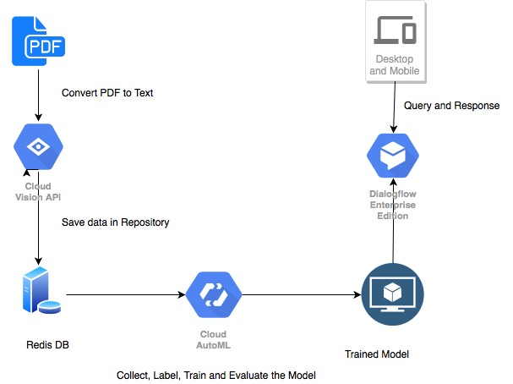

Create a **1-minute** video demo:

1. Capture a screen share of your product demo
2. ***Refer to FAQ for free tools you can use to record your screen***

***Deadline: Friday 5 July 11:59 PM EST***